|  |
| --- |
| Circle Language Spec: Commands |

## Clauses in Clauses in a Diagram

This article demonstrates a situation of command objects.

This article illustrates how clauses in clauses look in a diagram.

Because clauses are always part of a parent command, the parent command is displayed in the pictures below as the outer square. Inside the square is a clause, and inside that symbol are two clauses in a clause. Inactive clauses are squares. Active clauses are diamonds.

Inactive clauses in an inactive clause in a command definition:

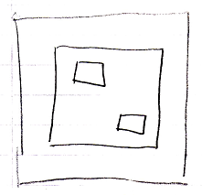

Active clauses in an inactive clause in a command definition:

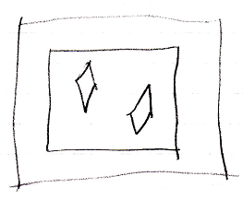

Inactive clauses in an active clause in a command definition:

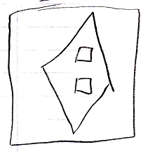

Active clauses in an active clause in a command definition:

